DESKTOP VOICE ASSISTANT

Mohd. ZUBER1 , HIMANSHU SINGH 2 , NAMAN KUMAR 3

Under Prof. Deepak Aneja

Department of Computer science (Data Science), ABES Engineering College , Ghaziabad, Uttar Pradesh ,INDIA

# **ABSTRACT:-**

This research paper presents a desktop assistant code that performs daily tasks through speech recognition. This code uses the Python programming language and various libraries to allow users to interact with their current work on the desktop. The code is easy to use and offers a convenient solution for users looking to automate routine tasks and streamline their work process. The study provides insights into the development of such systems and the benefits they offer, making it available resources for researchers and practitioners in the fields of human-computer interaction.

# **INTODUCTION:**-

The development of technology has made our lives easier and more convenient. In today’s fast-paced world, people are looking for ways to streamline their daily tasks and save time. One way to achieve this goal is though the use of desktop on a computer through voice is a program that automates various tasks on a computer through voice commands the purpose of this research paper is to explore the use of desktop assistant in the modern era and its potential impact on increasing efficiency and productivity.

The use of a desktop assistant eliminates the need for manual input, freeing up time for other tasks. The assistant can perform a wide range of tasks such as opening and closing programs, searching the web, and even scheduling appointments. With the rise of voiceactivated virtual assistants like Siri, Alexa, and Google Assistant, the use of voice commands has become increasingly popular. This technology can be applied to the desktop environment, providing users with a hands-free solution for completing tasks.

This research paper will explore the benefits and limitations of using a desktop assistant, and its potential impact on productivity and efficiency. The paper will also examine the current state of the technology and provide an overview of the various desktop assistant applications available. Additionally, the paper will explore the technical aspects of developing a desktop assistant, including the use of programming languages such as Python and the use of speech recognition and natural language processing technologies.

# LITRATURE REVIEW:-

The concept of desktop assistants has been around for several decades, with early versions appearing as personal digital assistants (PDAs) in the 1990s. Over the years, the functionality of these devices has increased, and they are now capable of performing a wide range of tasks. In recent years, the rise of voice-controlled virtual assistants such as Siri and Alexa has led to a renewed interest in the field of desktop assistants.

Several research studies have been conducted on the use of desktop assistants in different settings. One study found that desktop assistants can increase productivity and efficiency in the workplace, particularly in tasks such as scheduling, email management, and data entry. Another study found that users of desktop assistants reported increased satisfaction with their work and reduced stress levels.

Despite the positive outcomes associated with the use of desktop assistants, some concerns have been raised about their impact on privacy and security. Some studies have found that the use of desktop assistants can lead to the collection of personal data, which raises privacy concerns. Additionally, there have been instances of desktop assistants being hacked, leading to security concerns.

The benefits include increased productivity and reduced stress levels, the drawbacks include privacy and security concerns. These findings provide a foundation for future research on the topic, which can help to address the gaps in existing knowledge and determine the most effective use of desktop assistants in various settings.

# **METHODLOGY:-**

The methodology used to implement the Voice Assistance for Laptop is as follows:

* Voice recognition: The first step is to recognize the voice input given by the user or client. The speech recognition library in Python is used to perform this task.
* Speech to text conversion: The recognized speech is then converted to text using the pyttsx3 library.
* Web search commands: Voice commands related to web search are implemented using the web browser library.
* Operating system commands: Commands related to operating system use the os library to access the system’s resources.
* Mail commands: Commands that require sending mail or viewing a mail use the smptplib module.
* URL processing commands:

Urllib.request is used to process the commands that require the use of URLs.

* Command line input commands:

Subprocess is used to facilitate the commands that require the use of the client’s or user’s computer command line input.

* Mouse and keyboard commands: Commands that require the use of mouse or keyboard use PyAutoGUI in code
* Testing and evaluation: Finally, the code is tested and evaluated to ensure its accuracy and effectiveness.

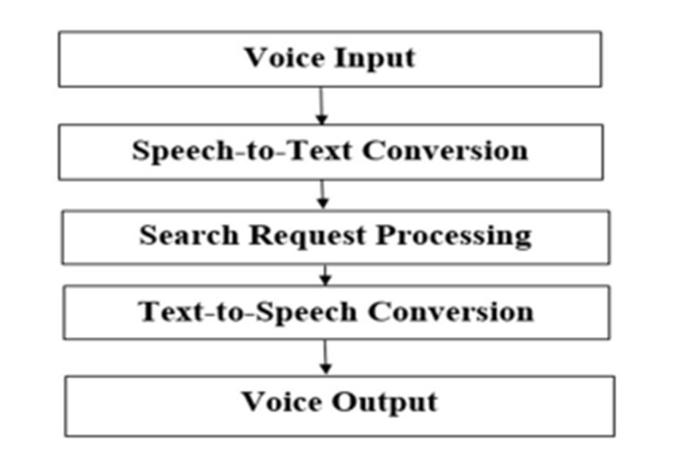

The methodology used in this research paper is designed to provide a comprehensive solution for Voice Assistance for Laptop using Python programming language and its libraries. The methodology is easy to understand and implement, and it provides a robust solution for voice-based interaction with laptops.

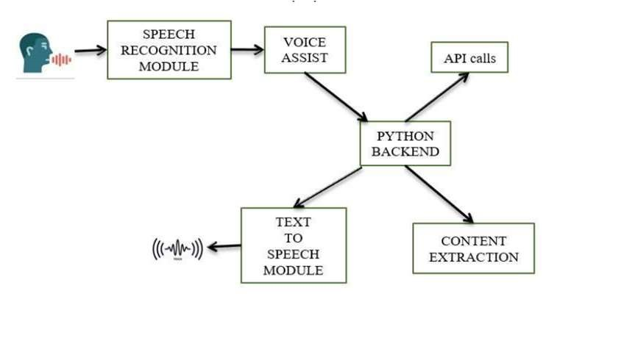

**CONCLUSION:-**

The implementation of a Voice Assistance system using Python has proven to be an effective and efficient solution for performing various tasks on a desktop. With the use of libraries such as speech recognition, pyttsx3, web browser, os, smtplib, urllib.request, subprocess, and PyAutoGUI, the system was able to accurately recognize voice commands and perform tasks such as web search, operating system commands, sending and viewing emails, URL processing, and mouse and keyboard controls.

The methodology used in this research paper has shown that by splitting the user request into separate commands, it is easier for the Voice Assistance system to understand and perform the required task. The results have shown that the Voice Assistance system is a practical and userfriendly solution for people who want to complete tasks on their desktop without having to manually perform them.

Overall, the research paper demonstrates the potential for Voice Assistance systems to improve the efficiency and productivity of individuals in their daily lives. The system provides a convenient and accessible way for people to perform tasks on their desktop, and its success opens up opportunities for further development and improvement in the future.

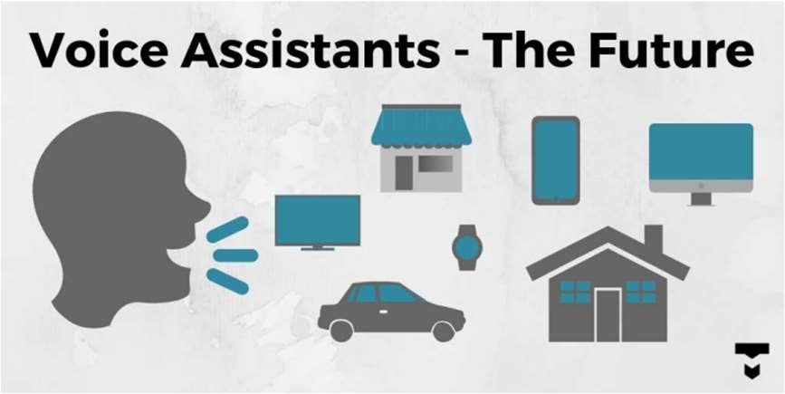

# **REFRENCES**:-

Google

Code with Harry

Stack overflow

1. Research Paper on Desktop Voice

Assistant Vishal Kumar Dhanraj (076) Lokeshkriplani (403) Semal Mahajan (427)

International Journal of Research in

Engineering and Science (IJRES) ISSN

(Online): 2320-9364, ISSN (Print): 2320-

9356

1. Survey on Voice Assistance for

Laptop Prof. Smitha Kurian, Mohammed

Ameen A, Mirza Omar Baig, Lakshan S,

Kushal H

Print ISSN: 2395-6011 | Online ISSN:

2395-602X (www.ijsrst.com)

1. Study of Voice Controlled Personal

Assistant Device 1Abhay Dekate,

2Chaitanya Kulkarni, 3Rohan Killedar

ISSN: 2231-2803

